**KAMPALA URBAN SCHOOLS**

**BEGINNING OF FEBRUARY EXAMINATIONS, 2024**

**PRIMARY FOUR MATHEMATICS**

**NAME:____________________________________STREAM:_______**

Section A

1. Add 13 + 5 =
2. Write 206 in words  
   __________________________________________________
3. Find the perimeter of the triangle below   
     
    7cm 7cm   
    7cm
4. Write 500 + 40 + 6 as a single numeral (figure)
5. Subtract 5 – 3 = _______  
    6 6
6. What is a 1 of 15   
    3
7. Multiply 3 4 3  
    x 3  
    _____
8. One book costs sh.100 what is the cost of 10 similar books.
9. How many days are in 12 weeks?
10. Fill in the missing number

+ 3 = 15

1. Jerry is 13 years old. His brother Martin in 6 years younger.  
   Find their total age?
2. Which month of the year comes between April and June?
3. Jeremy was born in 2000. How old was he in 2010?
4. 2 9 9  
   + 2 3 4  
   ______
5. One driver drove 89 miles to the first stop. He then drove 102 miles to the second stop. How many miles did he drive all together?
6. Write **three thousand five hundred fifty** in figures
7. Use the hour and minute hands to show 1:15 on the clock face

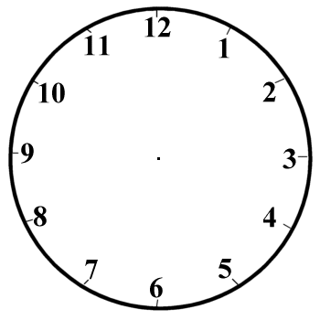

1. Set A= {Uganda, Kenya, Tanzania, Rwanda, Burundi}  
   How many members make up this set?
2. What time will the clock show in 10 minutes?

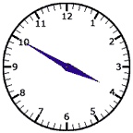

1. Divide correctly using long division 124 :- 4

1. **SECTION B**

21. a) What is the place value of 6 in the figure 34675 (2marks)

1. How many days are in 5 weeks? (2marks)

1. a) Circle the hexagon. (2marks)



b) A sandwich costs 2500 shillings. How much will I pay for 4 sandwiches? (2marks)  
  
  
  
  
  
c) 3 girls share 18 toys equally. How many toys will each girl get? (2marks)  
  
  
  
  
23 a) Tom has a toy car which is 15cm long. Peter also has a toy car which is 12cm long. What is the total length of their toy cars? (2marks)

1. b) Circle the correct number sentence that matches the stars. (2marks)



a) 5X 5 b) 5 X 3 c)3 + 3 + 3 + 3

c) How many triangles can you see? (2marks)

1. a) Colour the figure below to show the given fractions. (2 marks)



1. b) What fraction of the figure is **shaded**? (2marks)



1. a) At what time did Ali wake up? (2 marks each)



25b) There are 12 months in a year. Name the months that make up the first quarter of a year.  
  
 ____________________, __________________________, _________________

1. a) Our end of term exams started at 9:05am and ended at 12:05 am. How long was the exam? (1

b) Which day of the week comes three days after Wednesday?

1. One decade is equal to ten years. How many years do 4 decades equal to?

1. a) Complete the table correctly. ( 2 marks each)

|  |  |  |  |  |
| --- | --- | --- | --- | --- |
| Birds | 1 | 3 | _______ | 8 |
| No. of wings per bird | 2 | _______ | 24 | _____ |

1. The containers on the graph below contain water. Study the graph and answer the questions that follow. (2marks each)

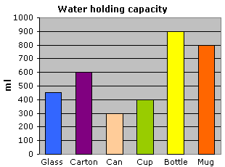  
a) How many containers are shown in the graph above?

b) Which container has the greatest amount of water?

c) What is the total amount of water in the bottle and mug?

1. Given that set X = {1, 2, 5, 7 } (2marks each)  
    set Y= {2, 3, 4, 5, 6 }
2. How many members are in set x?  
     
     
     
   b) Find X n Y = { }
3. Find X u Y= { }

30.Study the price list below and answer the questions below it. (2 marks each)

|  |  |
| --- | --- |
| **ITEM** | **PRICE** |
| A Pineapple | 3000= |
| A Pawpaw | 2500= |
| A Mango | 1000= |
| An Avocado | 700= |
| An Orange | 1000= |

1. Find the cost of a pawpaw and a mango?

1. Which item costs 2000=?

c) How much will you pay for 3 avocados?

31.Use **>**, **<**, or **=** to complete correctly. ( 1 mark each)  
  
a) 3 x 3 _____________ 2 x 3

b) 6 + 1 ______________ 5 + 3

c) 14 days _____________ 3 weeks

1. 1 day _____________ 24 hours

32.Sarah goes to pray at 9.00am and comes back home at 11.00am. ( 2 marks)  
 a) How many hours does she spend at church?

b) Match the time on the left with same time on the right. (1 mark each)

1. 4:05 five minutes past four

ii) 4:10 a quarter to four

iii) 3:45 ten minutes past four

END